NextField EOL to NextField Microsoft Fabric Reference Architecture Infographic
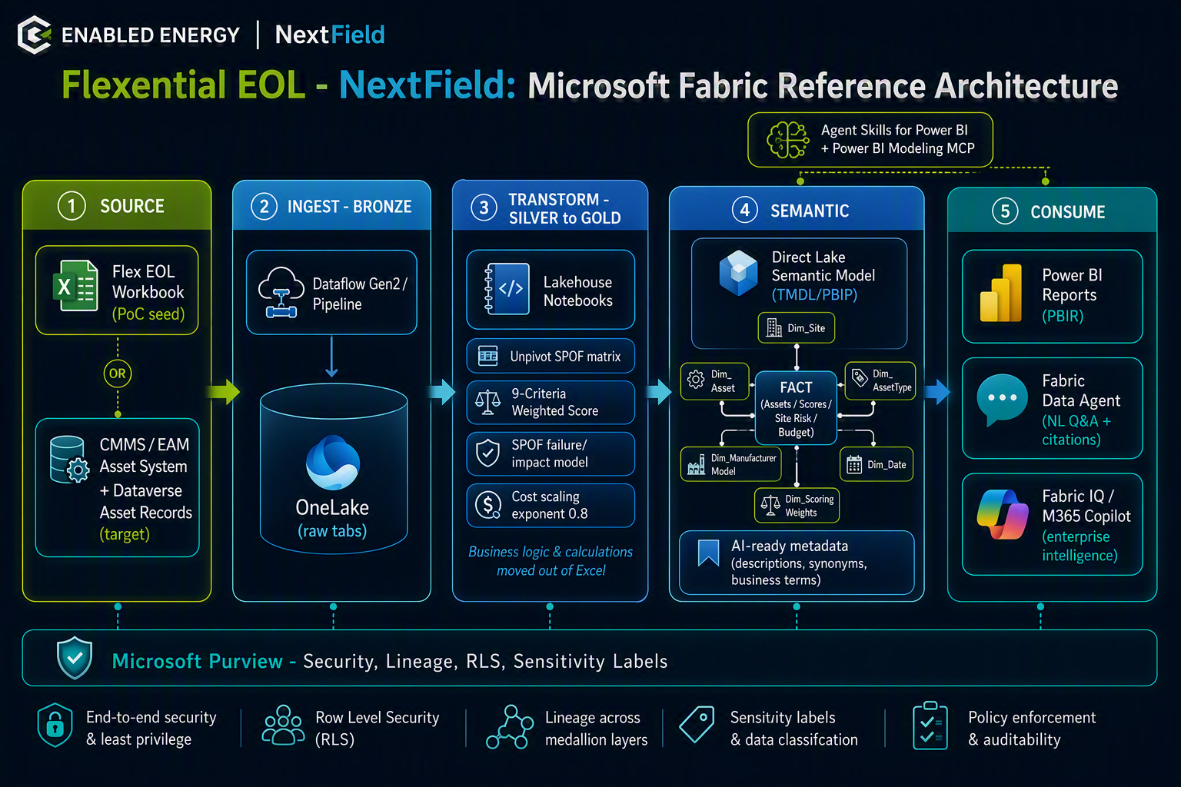
Let me fix both. The architecture diagram was generated inline but never saved as a downloadable file, and the TMDL needs re-presenting. Let me regenerate the diagram as a saved file and re-present both.Now let me save the diagram to a file on disk and re-package the TMDL as a .txt companion for easier download, then present both.Now let me present all three files. The .tmdl may have been the download issue (unusual extension), so I've added a .txt mirror.Both missing deliverables are now fixed:

1. Fabric Reference-Architecture Diagram ✅
The diagram is now rendered directly above (it was generated inline last time but never saved as a downloadable file). You can click it to view/save it full-size. It shows the five-column medallion flow — Source → Ingest/Bronze → Transform/Silver-Gold → Semantic (Direct Lake) → Consume — with the Purview governance bar and the Agent Skills + MCP callout.

2. Starter TMDL Semantic Model ✅
I've provided it in two formats since the .tmdl extension was likely what blocked your download:
- FlexEOL_NextField_SemanticModel_TMDL.txt — plain-text mirror, opens/downloads anywhere
- FlexEOL_NextField.SemanticModel.tmdl — the native TMDL file to hand straight to the Power BI Modeling MCP / drop into a PBIP project
Both are byte-identical (21 KB) — the 3 fact tables, 7 dimensions, the dynamic 9-criteria weighted score, what-if threshold params, and star-schema relationships built from the real workbook columns.

3. Word PoC Brief ✅ (re-attached for convenience)
FlexEOL_NextField_PoC_Brief.docx — the 8-page brief you already grabbed.
If the .tmdl still won't download on your end, the .txt version is guaranteed to open — just rename it to FlexEOL_NextField.SemanticModel.tmdl after saving and it'll work in a PBIP project. Want me to also bundle all three into a single .zip, or move on to the PowerPoint walk-through deck for Thursday?

